**EDUNET FOUNDATION-Class Exercise Notebook**

**LAB 1 – Transferring IOT Data to Cloud Services**

**Step 1: Create an account**

First of all, you will need to set up your Cumulocity environment (server).

* [**Register an account**](https://signup.softwareag.cloud/#_blank) on Cumulocity.
* Wait a few minutes after the registration, open your email account and look for an email with the subject 'Welcome to Cumulocity IoT'. Open it and **click 'Login to Cumulocity IoT'**.

[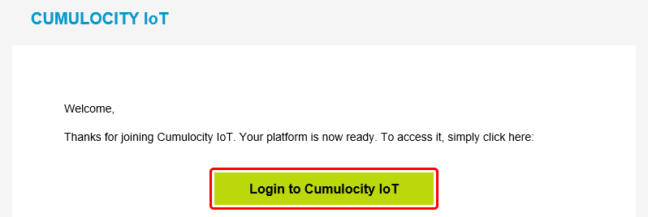](https://wiki.teltonika-networks.com/index.php?title=File:Networking_rutos_configuration_examples_cumulocity_1.png&filetimestamp=20200721072015&)

* Upon a successful login you should be redirected to the **Cumulocity Cockpit**.

[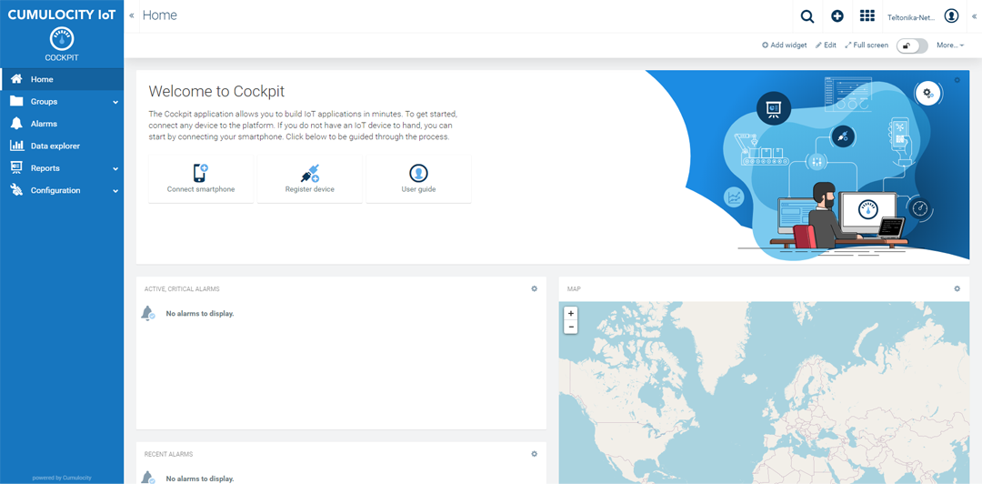](https://wiki.teltonika-networks.com/index.php?title=File:Networking_rutos_configuration_examples_cumulocity_2.png&filetimestamp=20200721080654&)

**Step 2: Connecting Smartphone Sensor Data to Cloud**

* On a desktop or laptop computer, open a web browser and log in to your Cumulocity IoT tenant. From the Cockpit application, click **Connect Smartphone** in the right drawer or in the Welcome widget.

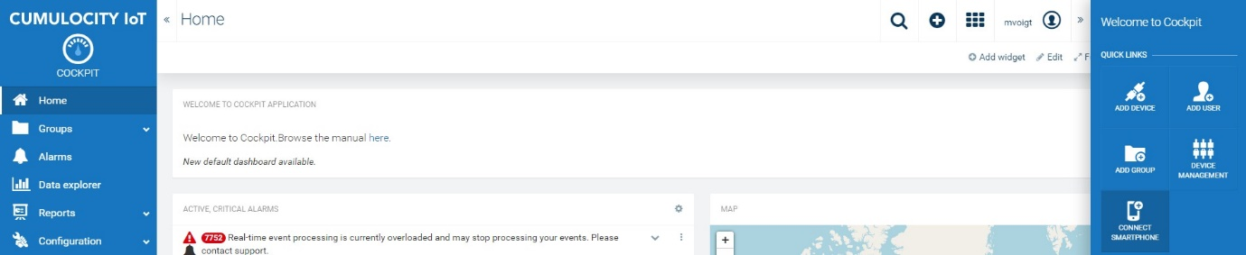

* Follow the instructions in the wizard, ensuring that the app is installed on the smartphone.

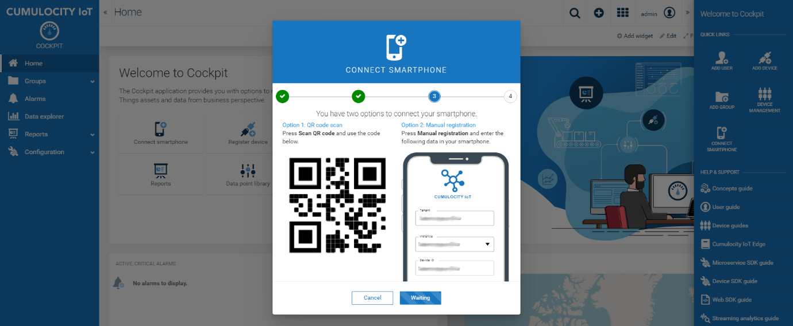

* From your smartphone, launch the app and tap **Connect** in the top right corner of the screen.
* Grant access to your camera if the app asks you for permission.
* Scan the QR code shown on your PC’s web browser. If you can’t scan the QR code, tap **Manual registration** on your smartphone and fill in the details at the right side of the wizard screen.
* Back on your smartphone, tap **Done**. Sensor measurements are sent to the server. They can be viewed in the device’s dashboard.

When using the **Connect Smartphone** wizard for device registration, your smartphone is automatically registered by Cumulocity IoT and assigned to the “Phones” group. Tap **Done** on your smartphone to return to the main screen.